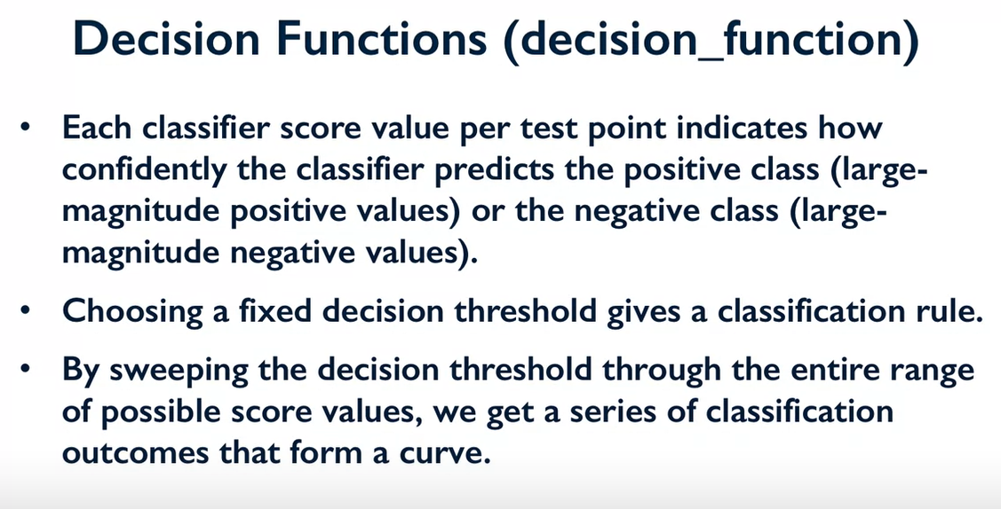

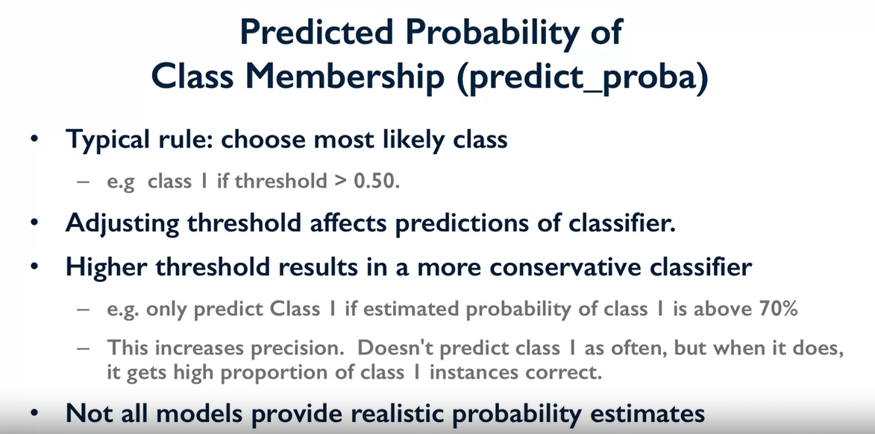

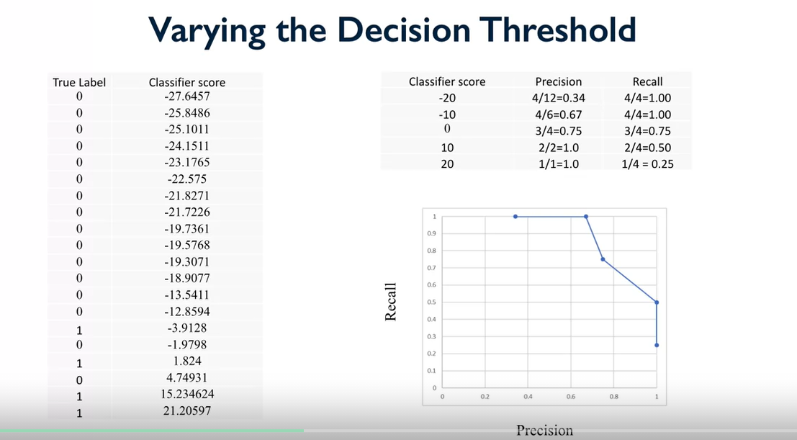

Curves

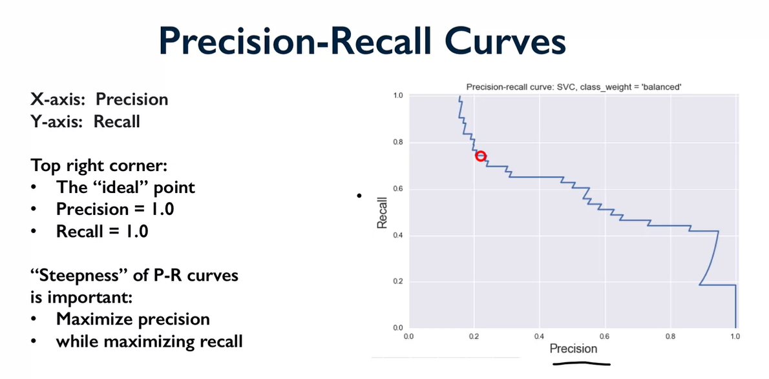

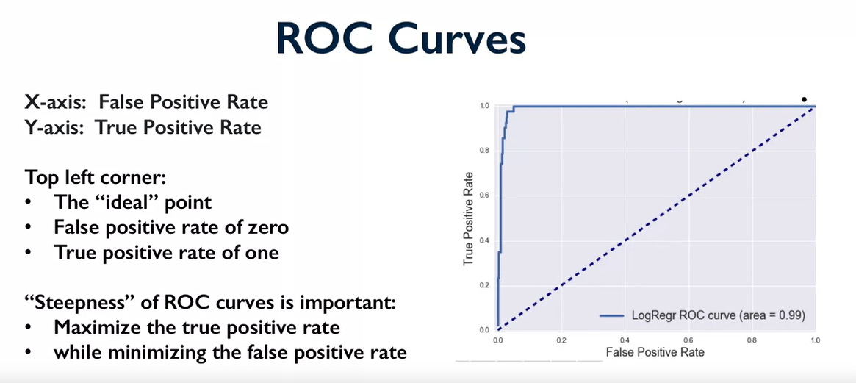

Multiple Class Evaluation

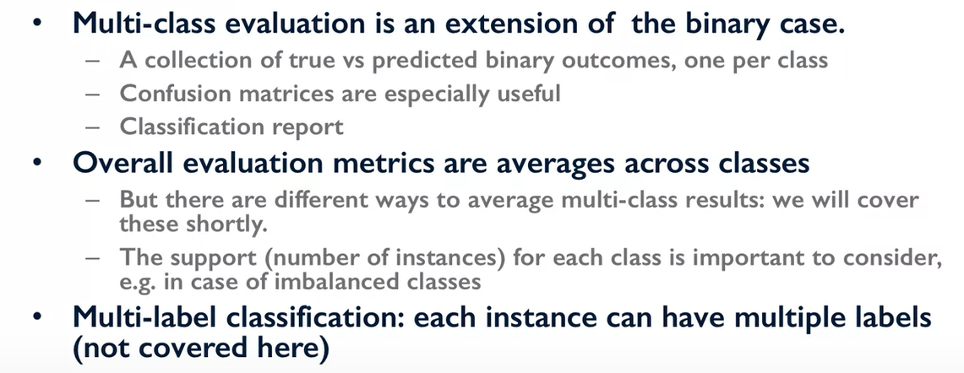
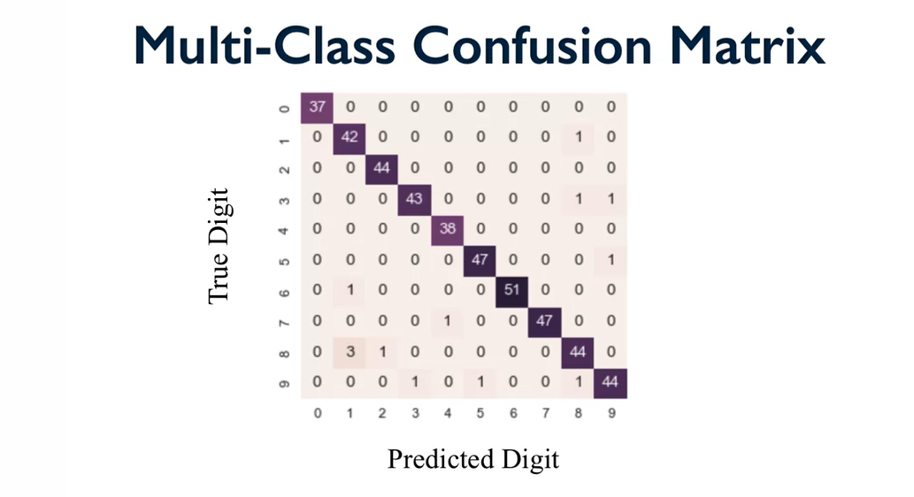

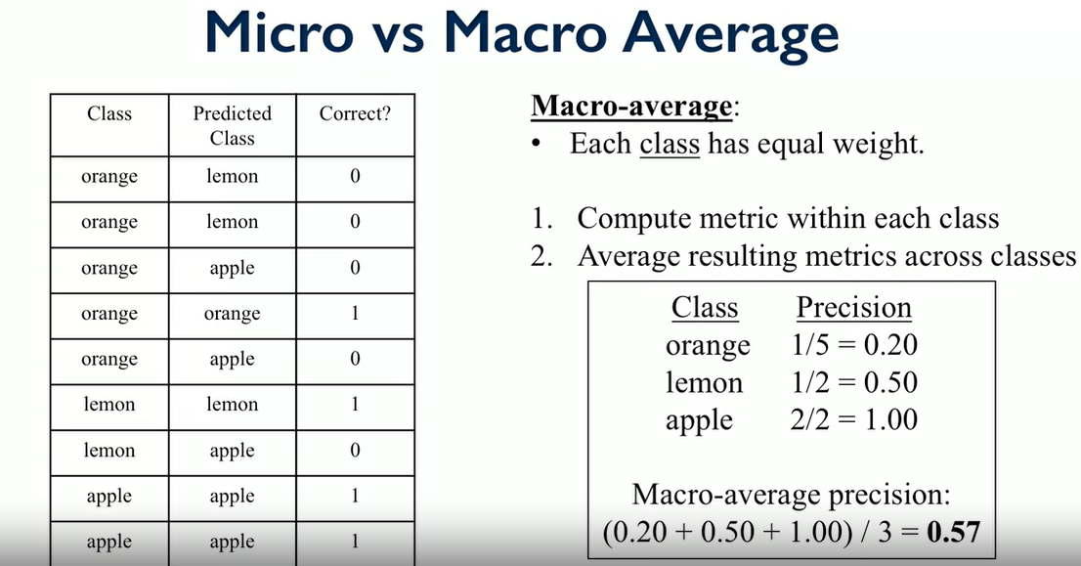

Micro-average & Macro-average Scoring Metrics - Python - Data Analytics (vitalflux.com)
Key takeaway:
- Micro-averaging and macro-averaging scoring metrics is used for evaluating models trained for multi-class classification problems.
- Macro-averaging scores are arithmetic mean of individual classes’ score in relation to precision, recall and f1-score
- Micro-averaging precision scores is sum of true positive for individual classes divided by sum of predicted positives for all classes
- Micro-averaging recall scores is sum of true positive for individual classes divided by sum of actual positives for all classes
- Use micro-averaging score when there is a need to weight each instance or prediction equally.
- Use macro-averaging score when all classes need to be treated equally to evaluate the overall performance of the classifier with regard to the most frequent class labels.
- Use weighted macro-averaging score in case of class imbalances (different number of instances related to different class labels).

